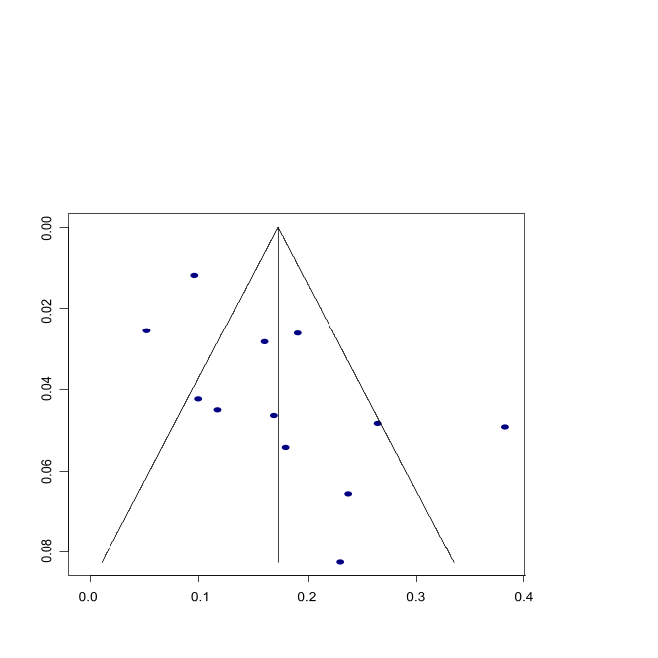
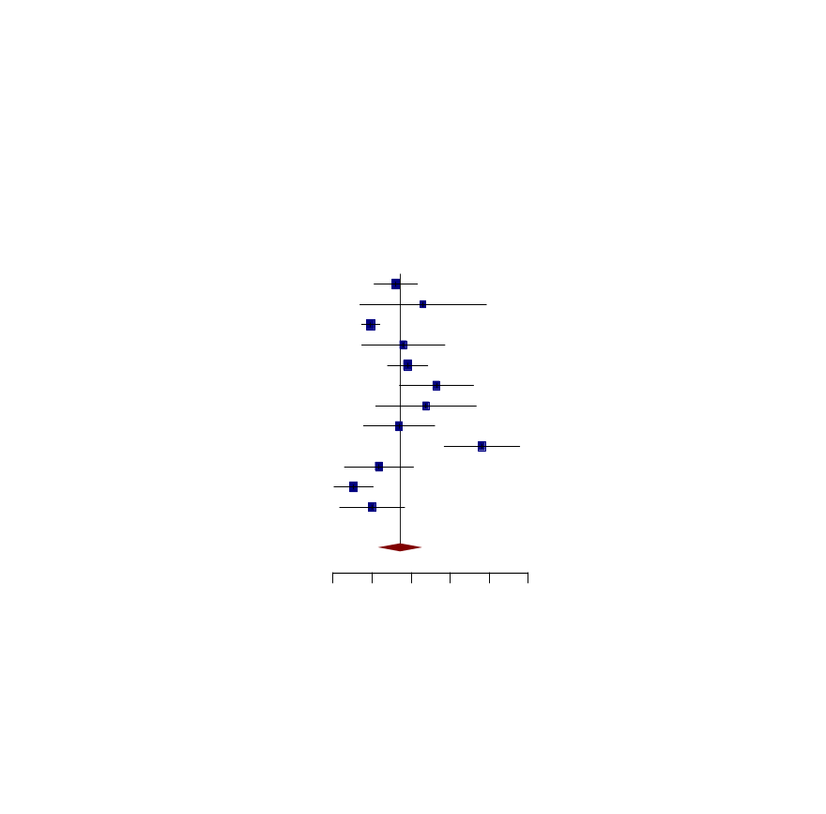
Figure 4
Funnel Plot for Publication Bias Assessment
Standard Error
Proportion
[27]
[126]
[67]
[16]
[127]
[117]
[70]
[65]
[68]
[72]
[69]
[26]
(B) Funnel Plot of Publication Bias
(A) Forest Plot of Individual Study
(D) Antibody Subgroup Analysis
(F) Geography Subgroup Analysis
(E) Sample size Subgroup Analysis
Study |  | Event | Total |  | Prevalence | 95% CI | Weight
Ademuyiwa et al [16] |  | 27 | 168 |  | 0.16 | [0.11; 0.22] | 9.9%
Tessari et al [26] |  | 6 | 26 |  | 0.23 | [0.07; 0.39] | 4.9%
Lee et al [27] |  | 59 | 612 |  | 0.10 | [0.07; 0.12] | 11.2%
Curigliano et al [65] |  | 9 | 50 |  | 0.18 | [0.07; 0.29] | 7.3%
Chen et al [67] |  | 43 | 225 |  | 0.19 | [0.14; 0.24] | 10.1%
Mrklic et al [68] |  | 22 | 83 |  | 0.27 | [0.17; 0.36] | 7.8%
Hamai et al [69] |  | 10 | 42 |  | 0.24 | [0.11; 0.37] | 6.2%
Raghavendra et al [70] |  | 11 | 65 |  | 0.17 | [0.08; 0.26] | 8.0%
Ceprnja et al [72] |  | 37 | 97 |  | 0.38 | [0.28; 0.48] | 7.8%
Xiao et al [117] |  | 6 | 51 |  | 0.12 | [0.03; 0.21] | 8.2%
See et al [126] |  | 4 | 76 |  | 0.05 | [0.00; 0.10] | 10.2%
Tanja et al [127] |  | 5 | 50 |  | 0.10 | [0.02; 0.18] | 8.5%
Random effects model |  |  | 1595 |  | 0.17 | [0.12; 0.23] | 100.0%
Heterogeneity: | I²=82.7%, τ²=0.005
 | χ²₁₂=6374 (p<0.0001)

0 0.1 0.2 0.3 0.4 0.5
Prevalence

(C) Leave-One-Out Meta-analysis
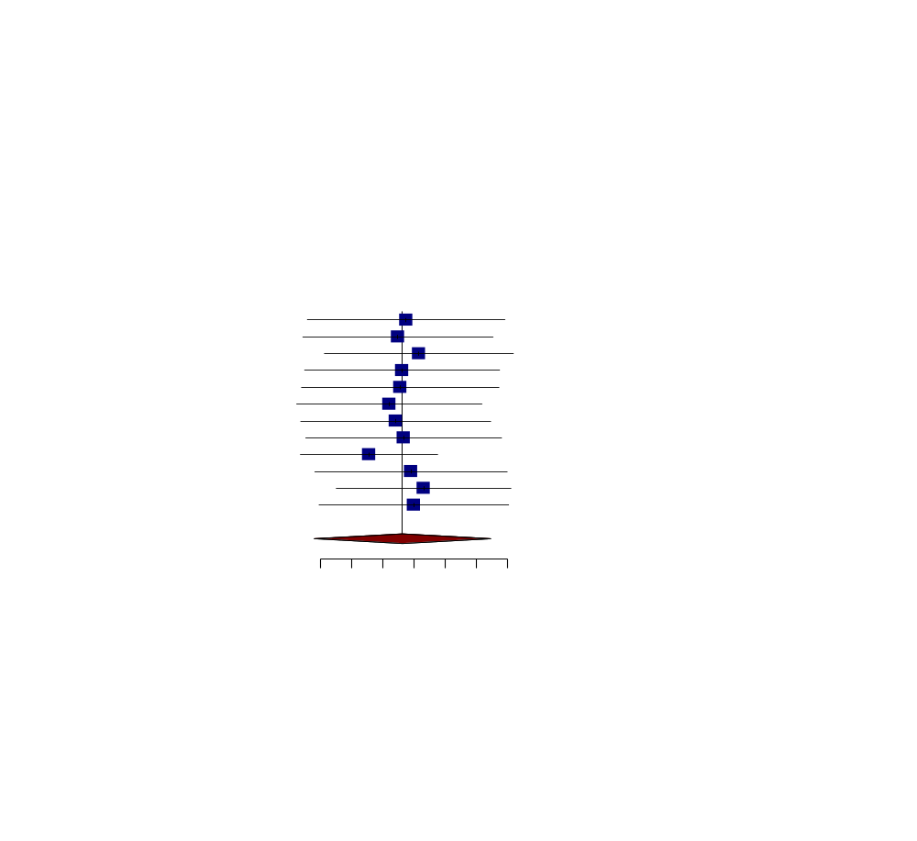
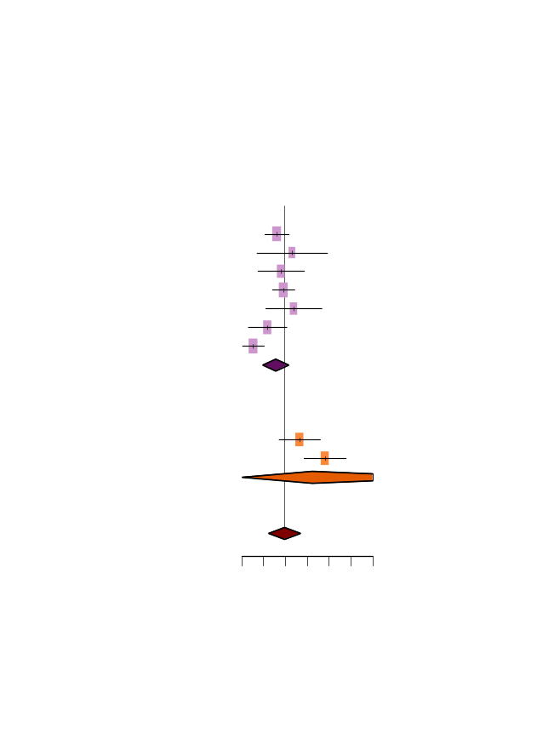
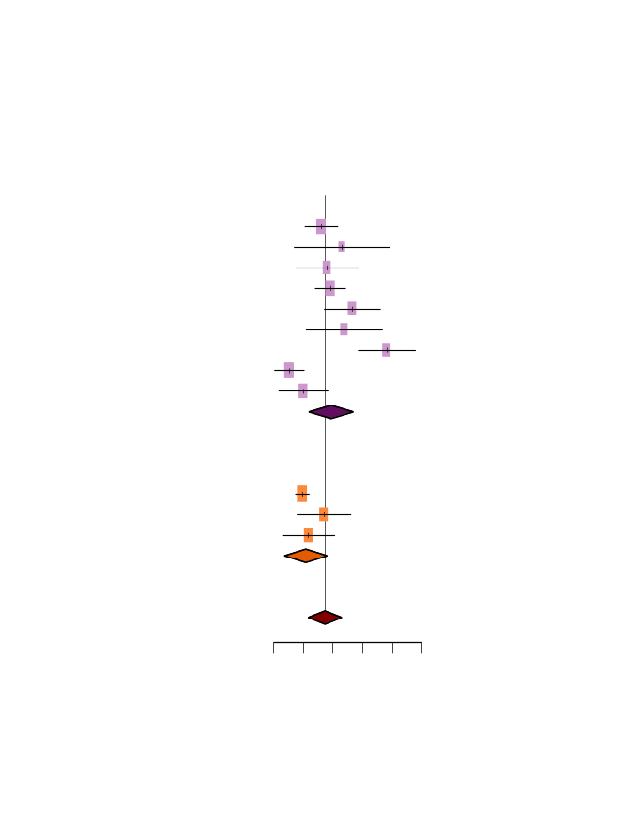
Study | Leave-One-Out  Meta-analysis | Proportion | 95% CI
Omitting [16] |  | 0.17 | [0.11; 0.24]
Omitting [26] |  | 0.17 | [0.11; 0.23]
Omitting [27] |  | 0.18 | [0.12; 0.24]
Omitting [65] |  | 0.17 | [0.11; 0.24]
Omitting [67] |  | 0.17 | [0.11; 0.23]
Omitting [68] |  | 0.16 | [0.10; 0.22]
Omitting [69] |  | 0.17 | [0.11; 0.23]
Omitting [70] |  | 0.17 | [0.11; 0.24]
Omitting [72] |  | 0.15 | [0.11; 0.20]
Omitting [117] |  | 0.18 | [0.12; 0.24]
Omitting [126] |  | 0.19 | [0.13; 0.24]
Omitting [128] |  | 0.18 | [0.12; 0.24]
Random effects  model |  | 0.17 | [0.12; 0.23]

0.12 0.14 0.16 0.18 0.20 0.22 0.24

0 0.1 0.2 0.3 0.4 0.5 0.6
Prevalence
Study | Event | Total |  | Rate | 95% CI
Subgroup = E978
[16] | 27 | 168 |  | 0.16 | [0.11; 0.22]
[26] | 6 | 26 |  | 0.23 | [0.07; 0.39]
[65] | 9 | 50 |  | 0.18 | [0.07; 0.29]
[67] | 43 | 225 |  | 0.19 | [0.14; 0.24]
[69] | 10 | 42 |  | 0.24 | [0.11; 0.37]
[117] | 6 | 51 |  | 0.12 | [0.03; 0.21]
[126] | 4 | 76 |  | 0.05 | [0.00; 0.10]
Random effects model |  | 638 |  | 0.16 | [0.09; 0.22]
Heterogeneity: I²=70.3%, τ²=0.003, p=0.003 |  |  |  | 0.16 | [0.09; 0.22]
Subgroup = D8.38
[68] | 22 | 83 |  | 0.27 | [0.17; 0.36]
[72] | 37 | 97 |  | 0.38 | [0.28; 0.48]
Random effects model |  | 180 |  | 0.32 | [0.00; 1.00]
Heterogeneity: I²=64.7%, τ²=0.004, p=0.092 |  |  |  | 0.32 | [0.00; 1.00]
Random effects model |  | 868 |  | 0.20 | [0.12; 0.27]
Heterogeneity:I²=82.9%, τ²=0.008, p<0.0001
Test for subgroup differences: χ²₁=7.06,
df θ (p=0.028)

Study | Event | Total |  | Rate | 95% CI
Subgroup = Western countries
[16] | 27 | 168 |  | 0.16 | [0.11; 0.22]
[26] | 6 | 26 |  | 0.23 | [0.07; 0.39]
[65] | 9 | 50 |  | 0.18 | [0.07; 0.29]
[67] | 43 | 225 |  | 0.19 | [0.14; 0.24]
[68] | 22 | 83 |  | 0.27 | [0.17; 0.36]
[69] | 10 | 42 |  | 0.24 | [0.11; 0.37]
[72] | 37 | 97 |  | 0.38 | [0.28; 0.48]
[126] | 4 | 76 |  | 0.05 | [0.00; 0.10]
[127] | 5 | 50 |  | 0.10 | [0.02; 0.18]
Random effects model |  | 817 |  | 0.19 | [0.12; 0.27]
Heterogeneity: I²=83.4%, τ²=0.008, p<0.0001 |  |  |  | 0.19 | [0.12; 0.27]
Subgroup = Asia-Pacific
[27] | 59 | 612 |  | 0.10 | [0.07; 0.12]
[70] | 11 | 65 |  | 0.17 | [0.08; 0.26]
[117] | 6 | 51 |  | 0.12 | [0.03; 0.21]
Random effects model |  | 728 |  | 0.11 | [0.04; 0.18]
Heterogeneity: I²=17.7%, τ²=0.001, p=0.297 |  |  |  | 0.11 | [0.04; 0.18]
Random effects model |  | 1545 |  | 0.17 | [0.12; 0.23]
Heterogeneity:I²=82.7%, τ²=0.005, p<0.0001
Test for subgroup differences: χ²₁=5.41,
df θ (p=0.020)

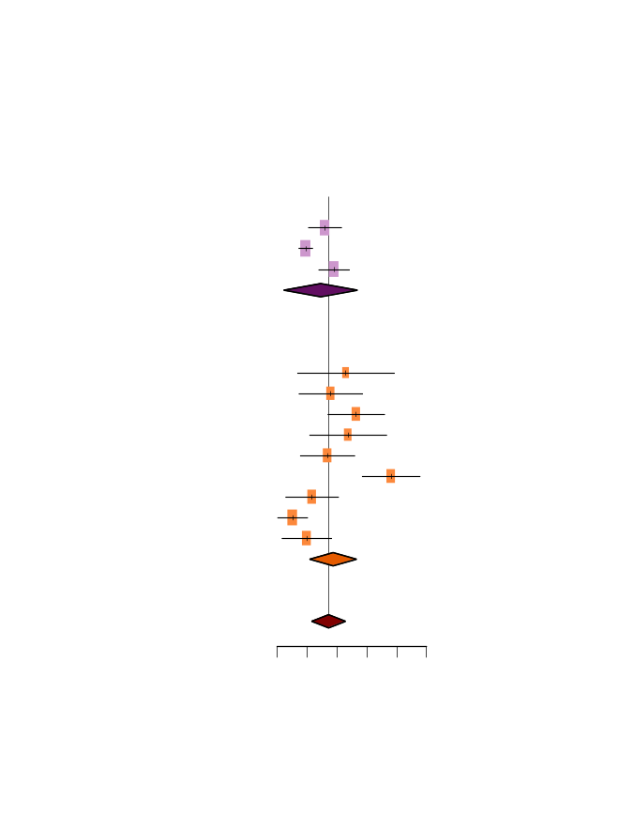
0 0.1 0.2 0.3 0.4 0.5
Prevalence
Study | Event | Total |  | Rate | 95% CI
Subgroup = Large (n≥100)
[16] | 27 | 168 |  | 0.16 | [0.11; 0.22]
[27] | 59 | 612 |  | 0.10 | [0.07; 0.12]
[67] | 43 | 225 |  | 0.19 | [0.14; 0.24]
Random effects model |  | 1005 |  | 0.15 | [0.02; 0.27]
Heterogeneity: I²=85.0%, τ²=0.003, p=0.001 |  |  |  | 0.15 | [0.02; 0.27]
Subgroup = Small (n<100)
[26] | 6 | 26 |  | 0.23 | [0.07; 0.39]
[65] | 9 | 50 |  | 0.18 | [0.07; 0.29]
[68] | 22 | 83 |  | 0.27 | [0.17; 0.36]
[69] | 10 | 42 |  | 0.24 | [0.11; 0.37]
[70] | 11 | 65 |  | 0.17 | [0.08; 0.26]
[72] | 37 | 97 |  | 0.38 | [0.28; 0.48]
[117] | 6 | 51 |  | 0.12 | [0.03; 0.21]
[126] | 4 | 76 |  | 0.05 | [0.00; 0.10]
[127] | 5 | 50 |  | 0.10 | [0.02; 0.18]
Random effects model |  | 540 |  | 0.19 | [0.11; 0.27]
Heterogeneity: I²=83.1%, τ²=0.010, p<0.0001 |  |  |  | 0.19 | [0.11; 0.27]
Random effects model |  | 1545 |  | 0.17 | [0.12; 0.23]
Heterogeneity:I²=82.7%, τ²=0.005, p<0.0001
Test for subgroup differences: χ²₁=0.88,
df θ (p=0.349)

0 0.1 0.2 0.3 0.4 0.5
Prevalence

